**UID LAB EXP 6**

**UI Design Lifecycle Using RAD Model for Sunshyn Toothpaste Interface**

**SHERYL KATRINA M**

**230701310**

**Aim:** To showcase the application of the Rapid Application Development (RAD) model in designing a UI for the Sunshyn toothpaste website using Axure RP. The goal is to visually replicate and simulate each stage of UI design with a focus on rapid prototyping.

**Simulating the Lifecycle Stages for UI Design Using the RAD Model**

The **RAD Model (Rapid Application Development)** emphasizes quick iterations and feedback loops through four key stages:

**1. Requirements Planning**

* **Objective:** Identify the essential features and layout of the Sunshyn toothpaste website based on the provided screenshots.
* **Analysis Based on Uploaded UI:**
  + **Navigation Bar:** Contains options such as Home, Shop, Concern, Kids, Learn, Search Icon, and Login button.
  + **Hero Section:** Vibrant product banner with a brand tagline and CTA (Call to Action) button.
  + **Category Section:** Showcases toothpaste types (e.g., Anti-Cavity, Daily Essentials, Fresh Breath, etc.) with clickable cards.
  + **Product Display Grid:** Shows various toothpaste types with images and pricing.
  + **Promotional Panels:** Offers, limited deals, and featured product highlights.
  + **Login Pop-Up/Modal:** Clean form with email, password, and login options.
* **User Stories:**
  + As a user, I want to browse toothpaste based on concern/type.
  + As a user, I want to view product pricing and packaging.
  + As a user, I want to securely login and access personalized features.

**2. User Design**

* **Tool Setup:**
  + Install and open Axure RP.
  + Start a new project named "Sunshyn Toothpaste UI".
* **Page Breakdown:**

1. **Homepage**

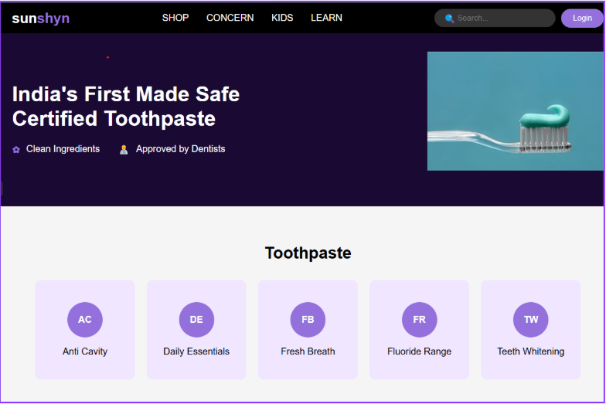

* + **Header/NavBar:** Includes Home, Shop, Concern, Kids, Learn, Search bar, and Login.
  + **Hero Section:** Large promotional image with brand messaging and CTA.
  + **Concern Category Cards:** Cards labeled AC (Anti-Cavity), DE (Daily Essentials), FB (Fresh Breath), FR (Fluoride-Free), TW (Teeth Whitening).
  + **Footer:** Contact info, social links, and quick links.

**b. Concern Category Page**

* + **Card Grid:** Users can select from different toothpaste categories. Each card links to its respective listing.

**c. Product Listing Page**

* + **Grid View:** Each product shown with name, price, and image.
  + **Hover Effects:** Highlights or shadows to indicate clickability.

**d. Product Detail Page**

* + **Optional but Recommended.**
  + Product description, benefits, price, size variants, and “Add to Cart” functionality.

**e. Login Modal/Page**

* + Fields: Email and Password.
  + Buttons: Login, Forgot Password, and optional Signup link.
  + Pop-up/modal style with blurred background overlay.
* 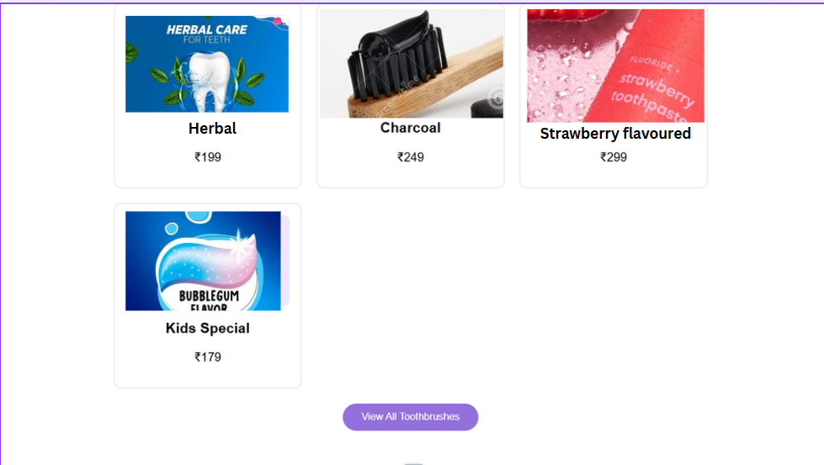**Wireframing and Prototyping Steps:**
  + Create master components for Navbar and Footer.
  + Add clickable interactions for navigation.
  + Implement modal triggers and hover effects using dynamic panels.
  + Annotate design elements for clarity and developer handoff.

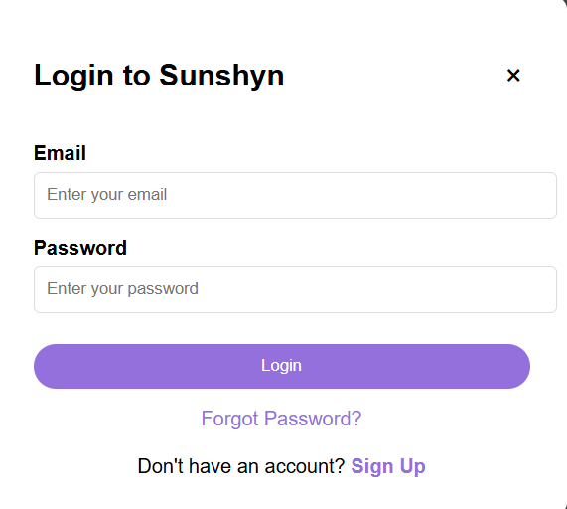

**3. Construction**

* **Prototyping in Axure:**
  + Add realistic navigation flows between pages.
  + Set up modal animations for the login.
  + Apply style guides (color, typography, spacing) based on brand aesthetics from the screenshot.
* **Interactivity Features:**
  + Navigation buttons lead to respective screens.
  + CTA buttons trigger transitions.
  + Modals appear dynamically upon clicking “Login.”
* **User Testing:**
  + Use Axure’s Preview or Share to gather feedback.
  + Conduct peer/user testing to identify UI bottlenecks or confusion.
  + Iterate based on suggestions.

**Conclusion:** This project outlines how to use the RAD model to design a professional, visually aligned UI prototype for the Sunshyn toothpaste website. By analyzing the screenshots and simulating features in Axure RP, we showcased how rapid prototyping, interaction design, and iterative feedback can bring a brand’s online presence to life.